**Chapter 6**

# Project Estimation and Schedule

**6.1 System Estimation Plan**

|  |  |  |  |  |
| --- | --- | --- | --- | --- |
| Sr  No | Name | Description | Timeline | Remark |
| 1 | Requirement Analysis. | Complete specification of the system | 19-Mar to  25-Mar | A detailed document should be there for each requirement. |
| 2. | High-Level Modelling | Identifies the modules and different entities and their relationships | 30-April to  28- May | Should decide on different modules and how they interact. |
| 3. | Detailed Designing | GUI design, Program  Specification |  | |
| 4. | Construction | Code for system, Implementation of different modules | 30-April to  28- May | Write code for different modules. |
| 5. | Testing | Test the different modules together | 04-June to 18-June | The system is tested using different test strategies |
| 6. | Deployment |  | 25-June | All requirements are fulfilled |

*Table 6.1: Project Estimation*

**6.2 Estimate**

Project estimation and project scheduling are carried out together without accurate scheduling estimation there is no foundation for effective planning and support for rapid development. There are three parameters involved in computing the total cost of a software development project.

1. Software Cost.
2. Testing.
3. Efforts

Our development schedule consists of the following steps.

1. Estimation of the size of the product.
2. Estimation of the effort (Man- months).
3. Estimation of the schedule (Calendar month).

**6.2.1 LOC based Estimation Effort.**

Project Estimation report is size oriented matrix. Here constructive cost model i.e. COCOMO is used to estimate effort and time duration by using the size of the software.

The Constructive Cost Model (COCOMO) is an algorithmic software cost estimation model developed by Barry W. Boehm. This model uses a basic regression formula with parameters which are derived from the historical project data and current project characteristics. COCOMO consists of a hierarchy of the three increasingly detailed and accurate forms. The first level, Basic COCOMO is good for quick, early, rough order of magnitude estimates of software costs, but this model’s accuracy is limited because of its lack of factors to account for the differences in project attributes (Cost Drivers). Intermediate COCOMO takes these Cost Drivers into the account and Detailed COCOMO having additionally accounts for the influence of individual project phases.

|  |  |  |
| --- | --- | --- |
| Sr. No: | File Name | Lines Of Code |
| 1 | App.vue | 6 |
| 2 | BookDetails.vue | 254 |
| 3 | BookTB.vue | 14 |
| 4 | Description.vue | 16 |
| 5 | History.vue | 8 |
| 6 | OrderSummary.vue | 6 |
| 7 | Error.vue | 12 |
| 8 | Checkbox.vue | 25 |
| 9 | Filter.vue | 66 |
| 10 | Header.vue | 43 |
| 11 | NavBarComponents.vue | 34 |
| 12 | Searchbar.vue | 37 |
| 13 | BookCoverCart.vue | 30 |
| 14 | LatsestBooks.vue | 29 |
| 15 | OrderCart.vue | 149 |
| 16 | OrderSummary.vue | 30 |
| 17 | ResultBook.vue | 191 |
| 18 | OrderDetails.vue | 71 |
| 19 | Siderbar.vue | 63 |
| 20 | OrderHistory.vue | 83 |
| 21 | Siderbar.vue | 60 |
| 22 | Profile.vue | 99 |
| 23 | Sidebar.vue | 60 |
| 24 | Profile.vue | 142 |
| 25 | Siderbar.vue | 54 |
| 24 | Wishbooks.vue | 170 |
| 25 | AddressPage.vue | 159 |
| 26 | LoginPage.vue | 132 |
| 27 | OtpPage.vue | 159 |
| 28 | RegisterPage.vue | 179 |
| 29 | cart.vue | 263 |
| 30 | Error.vue | 28 |
| 31 | BookView.vue | 114 |
| 32 | Home.vue | 235 |
| 33 | OrderDetails.vue | 179 |
| 34 | OrderHistory.vue | 87 |
| 35 | SearchResult.vue | 229 |
| 36 | UserProfileEdit.vue | 40 |
| 37 | UserProfileView.vue | 69 |
| 38 | WishList.vue | 120 |
| Total |  | 3745 |

*Table 6.2.1: LOC based Estimation Effort*

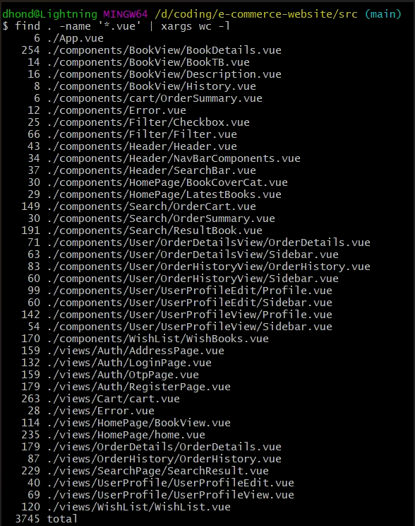

Lines of code per line with file location

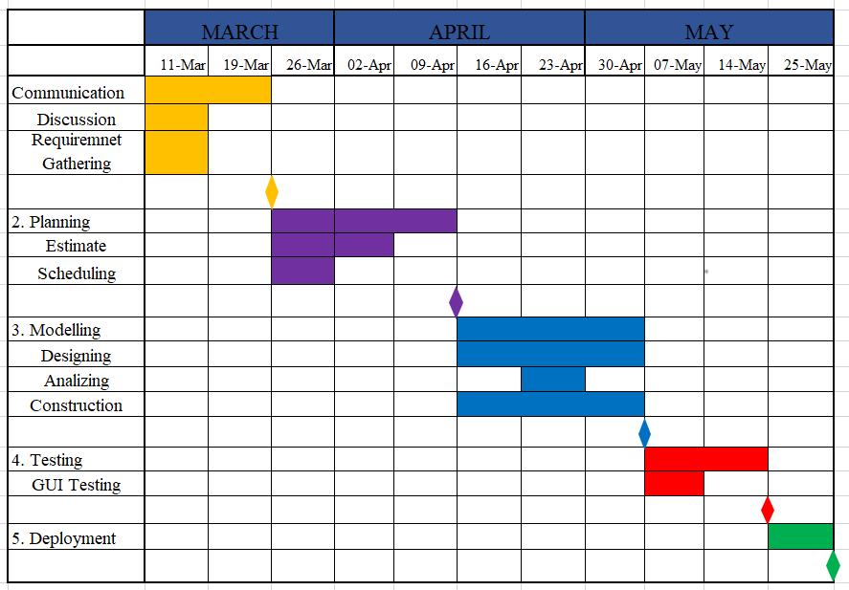**6.3 Schedule**

*Fig. 6.3: Time Estimation Gantt Chart*